Market Analysis of Eyeglass Data

Credits: Microsoft Copilot

# Recommendation

Explore Consumer Technology in Eyeglasses

Some of the latest innovations in eyeglass technology are aimed at enhancing the user experience and providing additional features. These include:

- Smart Glasses: These are glasses that can connect to the internet, display information on the lenses, take pictures and videos, and interact with voice commands. Some examples are Google Glass, Amazon Echo Frames, and Vuzix Blade.

- Augmented Reality (AR) Glasses: These are glasses that can overlay digital images and information on the real-world view, creating a mixed reality experience. Some examples are Microsoft HoloLens, Magic Leap One, and Nreal Light.

- Blue Light Blocking Glasses: These are glasses that can filter out the harmful blue light emitted by digital screens, reducing eye strain, headaches, and improving sleep quality. Some examples are Felix Gray, Gunnar, and Zenni.

- Smart Glasses: Would you like to access the internet, take photos, and control your smart devices with just your glasses?

- AR Glasses: Would you like to enhance your reality with immersive and interactive digital content on your glasses?

- Blue Light Blocking Glasses: Would you like to protect your eyes from the harmful effects of screen time and improve your sleep quality with your glasses?

# Summary of Findings

Here's a summary of the document:

**Main ideas:**

* **Age and style preferences:** Customers who prefer Sport-Protective and Eclectic styles are younger than customers who prefer Classic style.
* **Customer satisfaction factors:** Customers who consider Technology as an important factor have higher satisfaction levels than customers who consider Vision Change or Damaged Glass.

# What is the connection between age and eyeglass style?

I analyzed the data and found that the average age of customers varies by their preferred style. For example, customers who prefer Sport-Protective and Eclectic styles have an average age of 25.0, while customers who prefer Classic style have an average age of 50.6.

|  |  |
| --- | --- |
| **Preferred Style** | **Average of Average Age** |
| Classic | 50.6 |
| Modern | 45.5 |
| Vintage | 45.0 |
| Sport-Comfort | 42.5 |
| Eclectic | 25.0 |
| Sport-Protective | 25.0 |
| **Grand Total** | **43.5** |

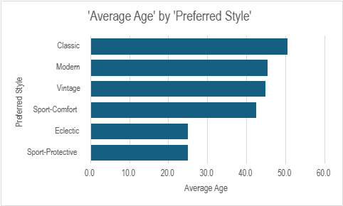

# What is the key factor in Customer Satisfaction? I analyzed the data and found that the average satisfaction level varies by the important factors customers consider when purchasing glasses. For example, customers who consider Technology as an important factor have an average satisfaction level of 5, while customers who consider Vision Change as an important factor have an average satisfaction level of 4.

|  |  |  |
| --- | --- | --- |
|  | |  |
|  | **Important Factors** | **Average of Satisfaction** |
|  | Technology | 5 |
|  | Vision Change | 4 |
|  | Damaged Glass | 3 |
|  | Style | 3 |
|  | **Grand Total** | **4** |

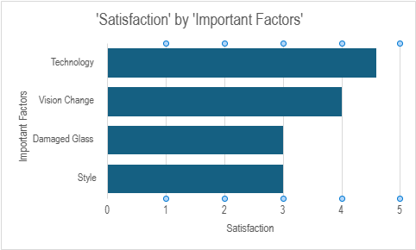

Consumer Technology in Eyeglasses   
(credits to Copilot Pro)

There are several important technologies in eyewear that are beneficial for consumers. Here are five of them:

1. **Blue Light Blocking Glasses**: With the average person spending a significant amount of time in front of screens, protecting our eyes from harmful blue light is crucial. [Blue light glasses are designed to filter out blue light, reducing eye strain and potentially improving sleep quality1](https://www.zennioptical.com/blog/trends-and-innovations-in-the-eyewear/).
2. **Smart Glasses**: These glasses incorporate features such as fitness tracking, augmented reality, and even prescription adjustments at the touch of a button. [They represent the next frontier in eyewear technology1](https://www.zennioptical.com/blog/trends-and-innovations-in-the-eyewear/).
3. **3D Printed Frames**: This cutting-edge manufacturing process allows for highly customized and perfectly fitted frames. [It’s a game-changer for both style and comfort1](https://www.zennioptical.com/blog/trends-and-innovations-in-the-eyewear/).
4. **Climate Conscious Eyewear**: Consumers are increasingly looking to reduce their impact on the environment. Some eyewear companies are responding to this trend by offering products that help consumers reduce their carbon footprint. [For example, some companies have launched sunglasses using CO2 polycarbonate lenses2](https://www.euromonitor.com/article/global-consumer-trends-for-2022-in-eyewear).
5. **Digital Platforms for Personalization and Convenience**: Online platforms are making it easier for consumers to personalize their eyewear. [Users can conveniently browse a myriad of styles, materials, and lens options to find the perfect pair that reflects their individuality and meets their optical needs1](https://www.zennioptical.com/blog/trends-and-innovations-in-the-eyewear/).

|  |  |
| --- | --- |
| Technology | Description |
| Blue Light Blocking Glasses | Designed to filter out blue light, reducing eye strain and potentially improving sleep quality. |
| Smart Glasses | Incorporate features such as fitness tracking, augmented reality, and prescription adjustments at the touch of a button. |
| 3D Printed Frames | Allows for highly customized and perfectly fitted frames, a game-changer for both style and comfort. |
| Climate Conscious Eyewear | Some companies offer products that help consumers reduce their carbon footprint, such as sunglasses using CO2 polycarbonate lenses. |
| Digital Platforms for Personalization and Convenience | Online platforms make it easier for consumers to personalize their eyewear, browsing styles, materials, and lens options to find the perfect pair. |

These technologies not only improve the functionality of eyeglasses but also enhance the wearer’s experience and eye health.